GBC BUS game has road, bus, car, and student object

The player controls a bus and he/she must avoid random coming cars, and try to collect points with getting students from the road. If the player collides with cars then will lose life and if collides with student he/she will get 100 points. The life for the player is 3 after it they will see their own score and the highest score. There is rest button to restart the game after game over.

User can control the bus using awsd, or the arrow key.

Starting the game would be an empty road with a bus which is the player. After that cars and students will appear. 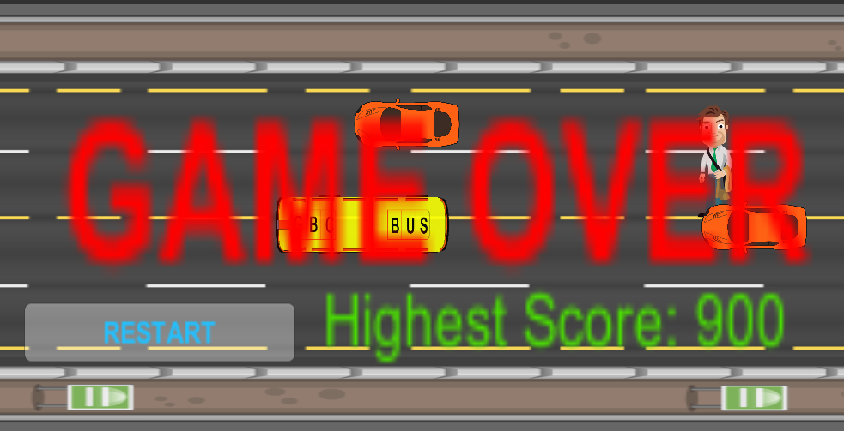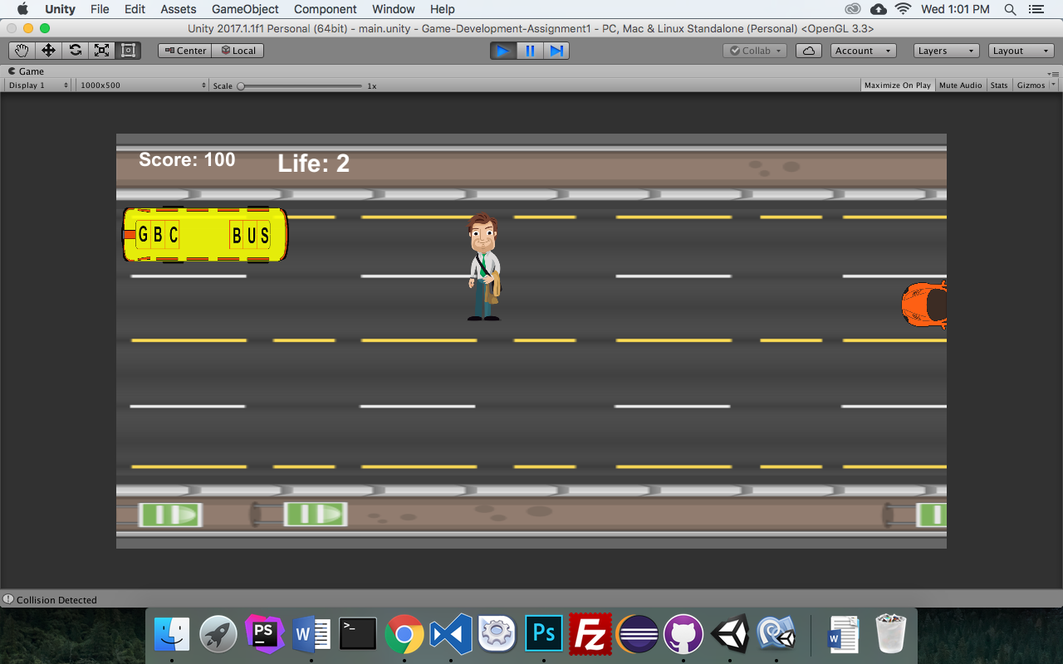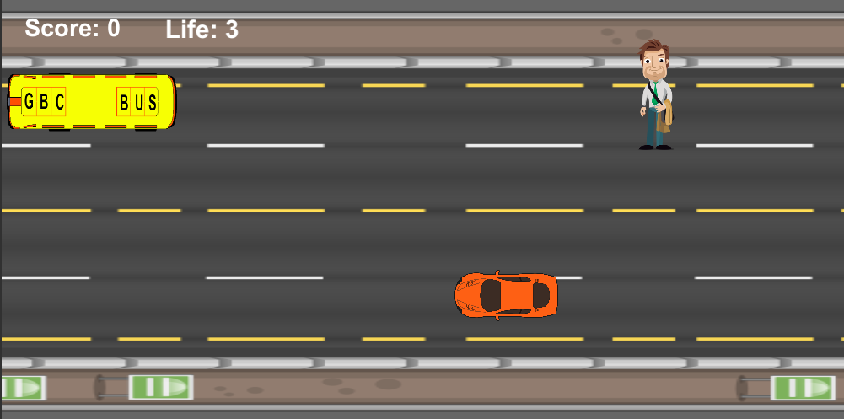

The enemies which are cars are coming in a random. They come in random location and speed.

For each student, the player gets 100 score.

There is sound playing when collision happens between the bus and car, or bus and student.

|  |  |
| --- | --- |
| Car | /Users/navidghasemnejadnaybin/Documents/Game-Development-Assignment/Game-Development-Assignment1/Assets/Textures/car.png |
| Student | /Users/navidghasemnejadnaybin/Documents/Game-Development-Assignment/Game-Development-Assignment1/Assets/Textures/student.png |
| Bus | /Users/navidghasemnejadnaybin/Documents/Game-Development-Assignment/Game-Development-Assignment1/Assets/Textures/bus.png |
| Road | /Users/navidghasemnejadnaybin/Documents/Game-Development-Assignment/Game-Development-Assignment1/Assets/Textures/background_road.png |